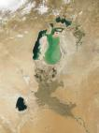

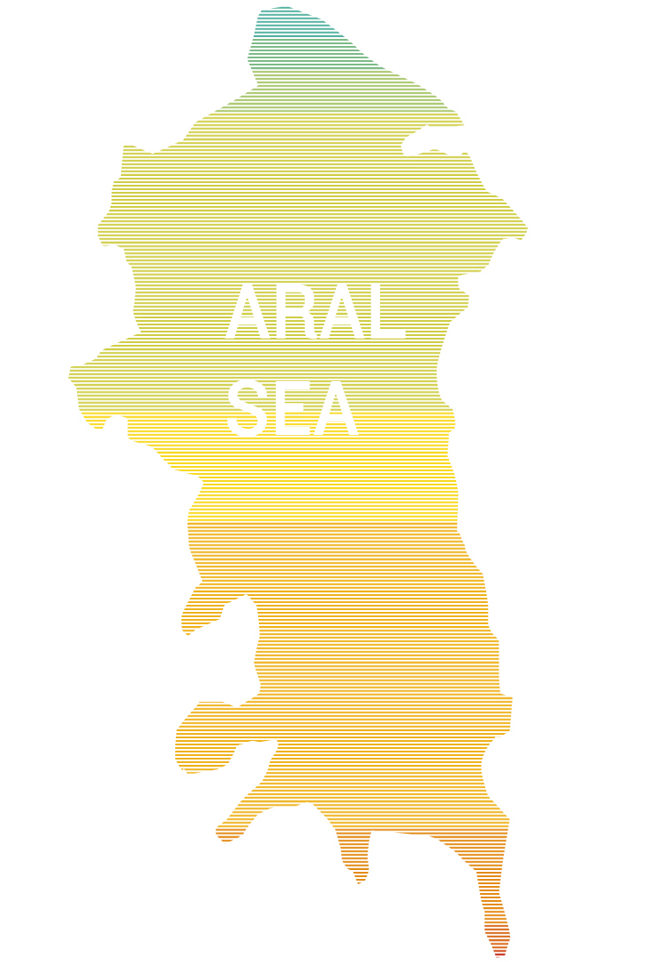

ON THE TOPIC: ABOUT THE ARAL SEA

MADE BY: 2-05 MNDT group
Hamroyev. F.

CHECKED BY: Tursunova. X

BUKHARA-2006


Central Asia is situated in the middle of the Eurasian continent at the crossroads of the old caravan routes which led from Europe to Asia and from the Middle and the Far East. It coincides mainly with the geographical boundaries of the Aral Sea Basin and includes the territories of Tadjikistan, Uzbekistan, a larger part of the territory of Turkmenistan, the Kyrgyz Republic and Kazakhstan. Since the 1960's, a sharp decrease of the Aral Sea level has been observed. This is connected with the intensive water consumption from the Syr Darya and Amu Darya rivers on agricultural lands. By 1990, the Aral Sea level had decreased by 14 m and the water volume had decreased three times.
As the water pulled back, new territory was formed. This area has a high content of sand, salt and waste.
Following their independence in 1991, the five Central Asian republics - Kazakhstan, Kyrgyzstan, Tadjikistan, Turkmenistan and Uzbekistan - requested assistance from the international community in finding a solution to the critical situation in the Aral Sea region.
In September 1995, the five heads of the Central Asian republics endorsed the Nukus Declaration that was signed at the end of a three-day international conference on "Sustainable Development of the Aral Sea Basin", held in Nukus, Karakalpakstan. Among other things they promised to devote more effort and funds to ameliorate the Aral Sea crisis and improve the lives of the millions of people affected by it.
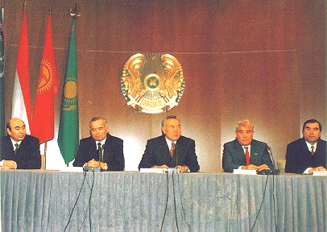
Further efforts of the 5 Central Asian states Presidents directed to the Aral Sea crisis liquidation were developed at the Alma-Aty and Ashgabad meetings and their declarations.
See: "Aral: yesterday and now". Problem and perspectives of the Aral crisis (photoalbum). Almaty, IFAS, 1997ю
At the meeting held in Alma-Aty on February 28, 1997 the presidents Nazarbaev N.(Kazakhstan), Akaev A.(Kyrgyzstan), Rahmonov A.(Tadjikistan), Niyazov S.(Turkmenistan) and Karimov I.(Uzbekistan)

Almaty manifest
We, Presidents of fraternal states of Central Asia - the Republic of Kazakhstan, the Kyrgyz Republic, the Republic of Tadjikistan, Turkmenistan and the Republic of Uzbekistan,
striving for independence and sovereignity in strengthening of our countries, and raising the
- living standards of the people,
- resulting from the fact that the ecological safety is one of the main components of the national security and the most important aspect of interests and priorities protection in the Central Asian states,
- taking into account that the ecological disaster problem in the Aral Sea basin is of global character and its solution can not be delayed,
- taking into account that the extreme ecological situation in the Aral region negatively influences the natural living environment and living conditions of millions of residents not only in the Aral Sea basin, but aso other regions of our planet;
- confirming our adherence to "Agenda for the 21st century" statements of the UNO world programme on environment supporting the tendency to work out and realize a single strategy on sustainable development of the Central Asian countries,
- recognizing that water resources management of transboundary rivers should have an ecosystem approach and be realized in a just and reasonable way without mutual damage, confirming the duties taken early for large scale cooperation at international and interstate levels,
- expressing the opinion of our countries, signed the Treaty on non-proliferation of nuclear weapons, and realize the necessity of declaring Central Asia a nuclear-free zone,
resulting from steady striving for common actions in the name of overcoming the consequences of ecological crisis in the Aral Sea basin, declared:
- the year of 1998 as a year of environment protection in the Central Asian region under the aegis of UNO
- on the eve of the 50-th anniversary of the Semipalatinsk test ground to call on all interested countries to support the idea of declaring Central Asia a nuclear-free zone open for joining by other states of the region,
- to mark efforts of the Central Asian states to undertake considerable measures for improvement of the ecological situation in the Aral Sea basin, in the region of the Semipalatinsk test ground and other zones being under nuclear test pressure, in spite of economic difficulties,
- to recognize the necessity of developing a complex programme of ecological safety including the Aral problem, to create a nuclear-free zone in Central Asia, and to struggle against nuclear technologies and raw material drain,
- to call on the UNO and its specialized agencies to pay great attention to the crisis situation in the Aral Sea basin and to undertake real measures to protect the environment in this region, drawing special attention to measures on rendering assistance to the grievous population of the Pre-Aral zone,
- to confirm readiness to promote international organizations and institutions in their activities to realize the programme of concrete actions and other regional projects,
- to complete together with international organizations the project development of the Convention on sustainable development of the Aral Sea basin

Ashgabad manifest
The meeting of Presidents of the 5 Central Asian states was held in Ashgabad (Turkmenistan) on April, 9, 1999. They confirmed the principles of the Alma-Aty declaration and outlined stages of task solutions in the future. The results of the meeting are reflected in the Ashgabad declaration.
On the threshhold of the 21st century humanity encountered drastic ecological problems impeding sustainable development. Degradation of environment is the result of irrational use of natural resources.
The consequences of the Aral crisis influenced negatively the life of the population in Central Asia, primarily by aggravating social protection and pure fresh water provision.
The Central Asian states pay persistent attention to the improvement of the situation in the region, and to the attraction of international attention to aid in solving the problem. In co-operation with international organizations the project "Water resources and environment management" is realized with support from the Global Ecological Fund (GEF). It is directed to radically improve the use of water and other resources, raise the efficiency and the culture of nature use in the region, and improve the ecological situation as a whole.
But the measures that have been taken so far to solve the Aral Sea problems have not been sufficient.
We, the Presidents of the fraternal states of Central Asia - the Republic of Kazakhstan, the Kyrgyz Republic, The Republic of Tadjikistan, Turkmenistan and the Republic of Uzbekistan,
- striving for providing well-being and belief in the future of our people,
- recognizing the necessity to work out joint measures in the regional strategy and specific actions on rational water resources use of the region based on ecosystem and integral principles of water economy activity,
- taking into account that water resources use in the basin of the Aral Sea should be observed according to the principles of neighbourhood and mutual interests by all parties,
- underlying the role of member-states of the Fund to strengthen cooperation in the field of water resources and environment protection management, and rehabilitation of water ecosystems, preventing transboundary water from pollution,
- confirming the measures taken on the joint realization of the specific action program on the Aral sea problems,
- confessing that public awareness is an important condition for agreed actions in ecological, social and economic policy in the region resulting from steady attempts to overcome the crisis consequences and improve the ecological situation in the basin of the Aral Sea together, declare:
- to recognize the significance of a complex problem solution connected with the improvement of social and ecological situation in the basin of the Aral Sea,
- to strengthen activity of the states and their representatives abroad for attracting attention of the international public, means and possibilities of state-donors, funds and organizations to programs and projects on the Aral Sea basin problems,
- to provide conceivable assistance and support of the World Bank and Global Ecological Fund project "Water resources and environment management in the basin of the Aral Sea",
- to pay more attention to problem solution of the mountainous territories - zones of river flow formation in the basin of the Aral Sea,
- to realize measures and projects of priority directions in social protection of the population inhabiting the basin of the Aral Sea
- to activate efforts directed towards the struggle against desertification and pollution of transboundary water,
- to promote international organizations and institutions in their activities in program and project realization in the basin of the Aral Sea,
to contribute to higher public awareness on actual problems of environment, rational nature use and improvement of living environments for the present and future generations through educational and other programs.



"Previous generations have always been anxious about the future, but we are the first who decide if the Earth inherited by our children will be inhabited".
Lester Brown, USA.
"The Aral crisis is the brightest example of the ecological problem with serious social and economic consequences, directly or indirectly connected with all the states of Central Asia. Critical situation caused by the Aral Sea drying off was the result of agrarian economy tendency on the basis of irrigated agriculture development and volume growth of irrevocable water consumption for irrigation".
Conference of the Central Asian region ministers. States of Central Asia: Environment Assessment. Aarhus, Denmark, 1998.
C entral Asia (territory is 1.7 mln. sq.km) is situated in the mid-part of Euroasia at the crossroad of ancient caravan routes between Europe and Asia, Middle and Far East and mainly coincides with the geographical borders of the Aral Sea, completely including territories of Tadjikistan, Uzbekistan, a large part of Turkmenistan, Kyrgyzstan and the south of Kazakhstan.
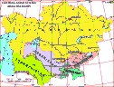
As one of the most ancient centres of world civilization, this region has vast territories of arid and semiarid zones(1 mln.sq.km) with only 5% of densely populated oases. The basin is inner water body of the dischargeless Aral Sea which was the fourth largest inland lake in the world before 1960. The dependence of the Central Asian civilization's development of water resources dates back to ancient times. Water and irrigation have always been the basis of life, the development of every living thing, and the main component of nature in the region.
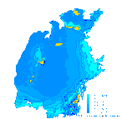
As a result of the complete stop of the AmuDarya and SyrDarya runoff and expansion of irrigated territories without any control of the Aral Sea and environmental needs, a serious complex of ecological, social and economic problems was formed in the Pre-Aral area. These problems by origin and level of consequences have an international character. The sea has lost its fishery and transport importance. It was divided into two parts, the Bolshoi and the Maly (Northern) Aral, and moved 100-150 km away from the original shore.
From exposed salty bed (35 thousand kmІ) up to 100 million tons of salty dust flew out annually. Suspended solids in the form of aerosols with agricultural pesticides, fertilizers and other harmful components of industrial and municipal wastes prevail in the composition of the winds.

Impact on climate regime
Sharp continental climate is a feature of the Pre-Aral area climate.
During the the last 5-10 years the drying off of the Aral Sea, brought about noticeable changes in climate conditions. In the past the Aral was considered a regulator mitigating cold winds from Siberia and reducing the summer heat. Climate changes have led to a dryer and shorter summer inthe region, and longer and colder winters. The vegetative season has been reduced to 170 days. The pasture productivity has decreased by a half, and meadow vegetation destruction has decreased meadow productivity 10 times. On the shores of the Aral Sea precipitation was reduced several times. Average precipitation magnitude is 150-200 mm with considerable seasonal ununiformity.
High evaporation (up to 1700 mm per year) is marked while air moisture is reduced by 10%. Air temperature during winters has fallen, and summer temperatures have increased by 2-3 degrees C, including observations of 49 degrees C.
Frequent occurence of long dust storms and ground winds is characteristic feature of the Pre-Aral area climate. Strong winds often blow in the region. They are the most intensive on the western coast - with perhaps more than 50 days of storms per year. Maximum wind velocity reaches 20-25 m/s.
These climatic conditions defined that agriculture without irrigation is impossible. The result is intensive accumulation of salt in the soil leading to water use for watering plants and washing off lands.

Impact on soil structure
M ost of the sands and soils in the Pre-Aral area are light and easily transported by wind.
The drying off of the Aral Sea resulted in two different kinds of desertification. The newly dried sea bed, and the artificial water logging of irrigated lands. As a result, a new desert "Aralkum" appeared in the centre of the great deserts. It is solid salt-marsh consisting of finely-dispersed sea depositions and remnants of mineral deposits, washed away from irrigated fields.
A new qualitative phase of desertification affecting the Pre-Aral ecosystem degradation, regional and global climate, mountainous flow-forming systems and water-salty regime of agricultural zone takes place.
The sea bed, formerly referred to as a so-called "fresh water maker" of vast water collecting basin at the expense of rich sea hydrobiocenose activity, is an artificial anthropogenous volcano, throwing tremendous masses of salt and finely-dispersed dust into the atmosphere. Pollution is increased because the Aral Sea is locatedalong a powerful air stream running from west to east. It contributes to aerosol transference into upper layers and fast spread in the atmosphere of the Earth. That is why traces of pesticides from the Aral region were found in the blood of penguins in the Antarctic, and typical Aral dust has been found on Greenland's glaciers, in Norway's forests, and Byelorussia's fields, all situated thousands of kilometers away from Central Asia.

Impact on cryosphere
O ne of the dangerous consequences of the drying off of the Aral Sea, is the increasing degradation of mountainous glaciers of the Himalaias, Pamir, Tien-Shan, and Altay, feeding the SyrDarya and AmuDarya.
The increase of dust on glacier surfaces and mineralization of precipitation on them lead to intensive melting of glaciers. At present, 1081 glaciers have disappeared in the Pamir-Altay area , 71 glaciers in the Zaili Alatau area, and the volume of glaciers in Akshirak has been sharply reduced.
On average, valley glaciers in the Tien-Shan area retreat 7.5-13.1 m per year and grow thicker at the same time. This is a dangerous process for a dry region, because in Central Asia, mountainous glaciers are the only ancient remaining storage of fresh water supply and are the main atmospheric moisture condensators of the region.
If the cover of moraine depositions increase, they no longer will be moisture condensators and sharp reduction of the river flow will start.

Impact on inhabitation sphere
T he Aral disaster has deteriorated the sphere of inhabitation of the region sharply, due to polluting of the atmosphere, the drinking water and the soil.
An evaluation of the field withdrawal from the dry parts of the Aral Sea bed shows that this magnitude varies from several hundred thousand tons to 20-30 million tons per year. In the composition of dust cloud suspended solids in the form of aerosols with agricultural pesticides, fertilizers and other harmful components of industrial and municipal sewage prevail. Salt content makes up 0.5-1.5%. Sand-and-salt aerosol effects on oasis soils and pastures are predominantly negative. Replacing multilayer herbage by single-layer, reduces the quantity of useful feeding plants, and often plants that have no feeding value are cultivated.
Two million hectares of fertile lands disappeared as a result of overwatering and as a result of fast rise of ground water they got polluted for the second time.
Today these lands are either water logged or salinized. Former arid soils of the Pre-Aral area with automorphic feed and moisture regime became meadow-swamp soils with hydromorphic regime. To support this regime artificially it is necessary to raise standards by 2-3 times, in order not to activate the secondary salinization process. A vicious circle of agriculture was formed in this region, where heavy swamped lands are left.
The land-improvement condition of irrigated soils in Central Asia is worsened by collective-drainage water saturated with pesticides and discharged as return runoff into numerous local landscape depressions. As a result, artificial reservoirs-accumulators appear. These reservoirs are a real disaster for surrounding lands. Some of them cause secondary pollution when poisonous bed depositions become dry and are brought on irrigated lands, ruin them and pollute the atmosphere in the surrounding regions.
The most spread pollutants in the Aral Sea are: oil hydrocarbons, phenols, synthetic surface-active substances (SSAS), chlororganic pesticides (COP), heavy metals and minerals. The abundant use of pesticides with high physiological reaction (B-58, metaphos, corotan, butiphos, hexachloran, lindan, DDT etc.) poses a tremendous threat to living organisms. Reservoirs carrying water with undecayed compounds of heavy metals and chlororganic pesticides, led to the destruction of fishery, the appearance of cancerogenic diseases, and changes in citogenetic indices.
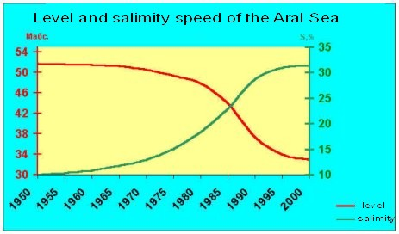
The maximum pollution level by oil hydrocarbons in 1970 was 54 MPC (maximum permissible concentration) in the Maly Aral (MPC=0.05 mg/dmі), and 80 MPC in the Bolshoi Aral. Since 1978 the tendency to oil hydrocarbons pollution stabilization at the level of MPC is marked. Phenols made up 28 MPC (MPC=0.001 mg/dmі)in the Maly Aral, and 63 MPC in the Bolshoi Aral. At present there is no information about phenol pollution because observations have been stopped. Concentrations of SSAS and heavy metals do not exceed MPC.
Salinization increased from 10 g/l to 40-50 g/l because of lack of fresh water inflow.

Impact on biodiversity
I n the past the uniqueness of the Aral Sea contributed to richness and diversity of the biota which could be compared with Africa. The Pre-Aral area possessed half of the biological species of the former USSR, many of these, however, have disappeared or are threatened. There were 500 kinds of birds, 200 species of mammals and 100 species of fishes, thousands of insects and invertebrates.
Before 1960 the river deltas were home to over 70 kinds of mammals and 319 types of birds. At present only 32 kinds of mammals and 160 types of birds remain. In lowstreams of the SyrDarya River, more than 100 thousand hectares of alluvial soils became salt-marsh, and more than 500 thousand hectares of swamp and medow-swamp soil became dry. This resulted in the transformation and destruction 5-7 kinds of herbs needed for fodder for sheep, horses, camels and goats. Diseases and death of cattle began, musk-rats cultivation stopped, and sheep live-stock decreased sharply.
The regional flora is impressive and includes 1,200 flowers, 560 types of tugai forests of which 29 are endemic to Central Asia. The flora of the Aral-Sea coast includes 423 kinds of plants of 44 families and 180 genera. The highest diversity of sand vegetation is concentrated on the former islands of the western coast. The dry strip of the Aral is characterized by lower diversity in comparison with the coast. Among them are 30 species which are valuable fodder plants, 31 kinds of weeds, and more than 60 kinds of local flora are potential phytomeliorants for dried coasts. The change in water balance caused mineralization of the water in the Aral Sea basin, which led to the loss of unique biocenosis and a number of endemic species of animals.
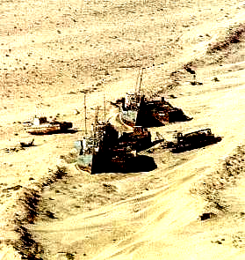
Inflow reduction into the Aral caused irreversible changes of hydrological and hydrochemical sea regimes and hydrosystems. Salt balance changes increased the sea salinity 3 times, transforming it into a desert. The formerly flourishing sea ecosystem supported 24 species of fishe that are disappearing. These include carp, perch, sturgeon, salmon, sheat-fish and spike. There were 20 kinds of fish in it, but fishery was based mainly on bream, sazan, aral roach (vobla). Barbel and white-eye fish were caught in the Aral Sea.
The first signs of the negative impacts of salinization on ichtyofauna of the Aral Sea, appeared in the mid 1960's when salinity reached 12-14%. On shallow water the salinity of water increased faster than in the open parts of the sea, negatively affecting spawning places. By 1971 the average salinity exceeded 15% and resulted in the destruction of fish spawn. Since 1971 the average salinity has reached 12% in the open part of sea, and the first signs of negative impact on fish have appeared. Some kinds of fish have slowed their growth, and the number of fish has been sharply reduced. By the mid 1970's average salinity of the sea exceeded 14%, and the natural reproduction of the Aral fish was completely destructed. In the late 1970s several species of fish did not reproduce at all. By 1980 salinity exceeded 18%.
The Aral Sea has lost its fishery completely. Of the ichtiofauna of the Aral Sea, only aboriginal species - pricles and acclimatizers - bullheads and sprats are left. In the estuaries of the SyrDarya and AmuDarya grown up fishes were caught occasionally. The researchers of the Aral department of the Kazakh Research Institute of Fishery in the 70's collected eurigaline and saltloving kinds of fish. They conducted experiments with Caspian sturgeons, Kurine salmon, Asov and Black sea plaice-glossa and plaice-kalkan. The most promising were the experiments with plaice-glossa having ecological plasticity, spawned at the places with 17% to 60% of salinity, at present its catch makes up 30% of the total number. Plaice quality is very high, and Dutch research showed that there are no traces of pesticides and heavy metals in them.

Impact on ecosystems
T he Pre-Aral area is characterized by a complex spatial structure of ecosystems. These are influenced by the physical and geographical conditions of the region, the consequences of its economic utilisation during many centuries, and the active influence of modern anthropogenous processes. Pre-Aral ecosystems are developing in extreme conditions of desert. The factors limiting biota development were established by nature itself. The Pre-Aral area has suffered from anthropogenous processes for a long time, both regionally and locally. Anthropogenous impacts have caused transformations of natural ecosystems which finally led to dramatic changes and degradation.
The ecosystems of delta valleys have been transformed greatly by agricultural land use for many centuries. Irrigated or cultivated fields, rice fields and non-cultivated agricultural lands which are characterized by different stages of soil and vegetation cover rehabilitation, are singled out. The following anthropogenic factors that brought about changes in the ecosystems should be considered according to their significance: pastures, land-use, agriculture, transport, city, rural, military objects, hydrotechnical (artificial reservoirs, dams, canals, sewage accumulators), and cattle-breeding.

Impact on the social and economic spheres
T he process of degradation in the Aral region caused progressive crises in the social and economic spheres. The primary victims of the crises were the most vulnerable layers of population, namely children, women, ill-paid inhabitants of cities and rural areas. The region has the highest child mortality rate in the former USSR (75 children per 1000 newly born), high level of maternity death: about 120 women per 10,000 births. Diseases such as TB, infections and parasites, typhus, hepatite, paratyphoid always accompany poverty.
The disease rate has a tendency to increase. In the epicentre of ecological disaster, anemia, disfunction of thyroid the gland, kidney and liver diseases are wide spread. Blood, oncological diseases, asthma and heart diseases are progressing. Medical research proves that the incidence and growth of these diseases are directly dependent on ecological disaster.

Neutralization of the Aral crisis
S ince the 1980's the cultivation of new large irrigated areas was banned and large-scale water resources projects have been introduced. At the same time measures to improve living conditions in the Pre-Aral area have been adopted at the expense of the construction of health-protection objects, water-supply, gasification, improved social care, and the watering of the AmuDarya and SyrDarya deltas. As a result 10.3mі and 12.56 mі went into the Pre-Aral area in 1995 and 1996 respectively. The AmuDarya River delta recieved 5.1 mі in 1995 and 7.46mі in 1996. This water was stored in artificial reservoirs in the AmuDarya delta, preventing desertification in the Pre-Aral area.
The first attempt to create the Maly Aral took place 1992, when the "Karateren-Kokaral" was constructed. But it collapsed in 1993 as a result of an increase of the water level. It was however restored.
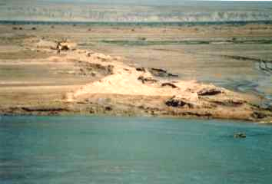
crosspiece "Karateren-Kokaral"
The crosspiece divided the Aral Sea into two parts: the Bolshoi Aral and the Maly Aral. The SyrDarya waterflows into the Maly Aral and slowly filled its dry bed. The water level rose by 1.5 m, and the growth of salinity stopped at the level of 5 g/l. The water came to the city Aralsk covering a distance of 10 km. The first signs of improvement in the ecological situation appeared: It rained more often, vegetation cover rehabilitation took place in the coastal area, the level of sea water salinity was reduced in a new-born reservoir, giving the opportunity of fresh fish supplies.
In 1999 this crosspiece was destroyed.

